**Assignment -1**

**THE CASE OF 50 STARTUPS**

|  |  |
| --- | --- |
| Batch Number | 11 |
| Student Name | MANJULA S |
| Student Roll Number | 921319104110 |

**Overview**

We will be exploring the profit from the startup’s dataset with the features available to us. We’re using the 50-startups dataset for this problem statement.

This particular dataset holds data from 50 startup’s in New York, California, and Florida. The features in this dataset are R&D spending, Administration Spending, Marketing Spending, and location features, while the target variable is: Profit.

**Challenge:**

Upload the dataset to Cognos analytics, explore and visualize the dataset.

1. **R&D Spending**

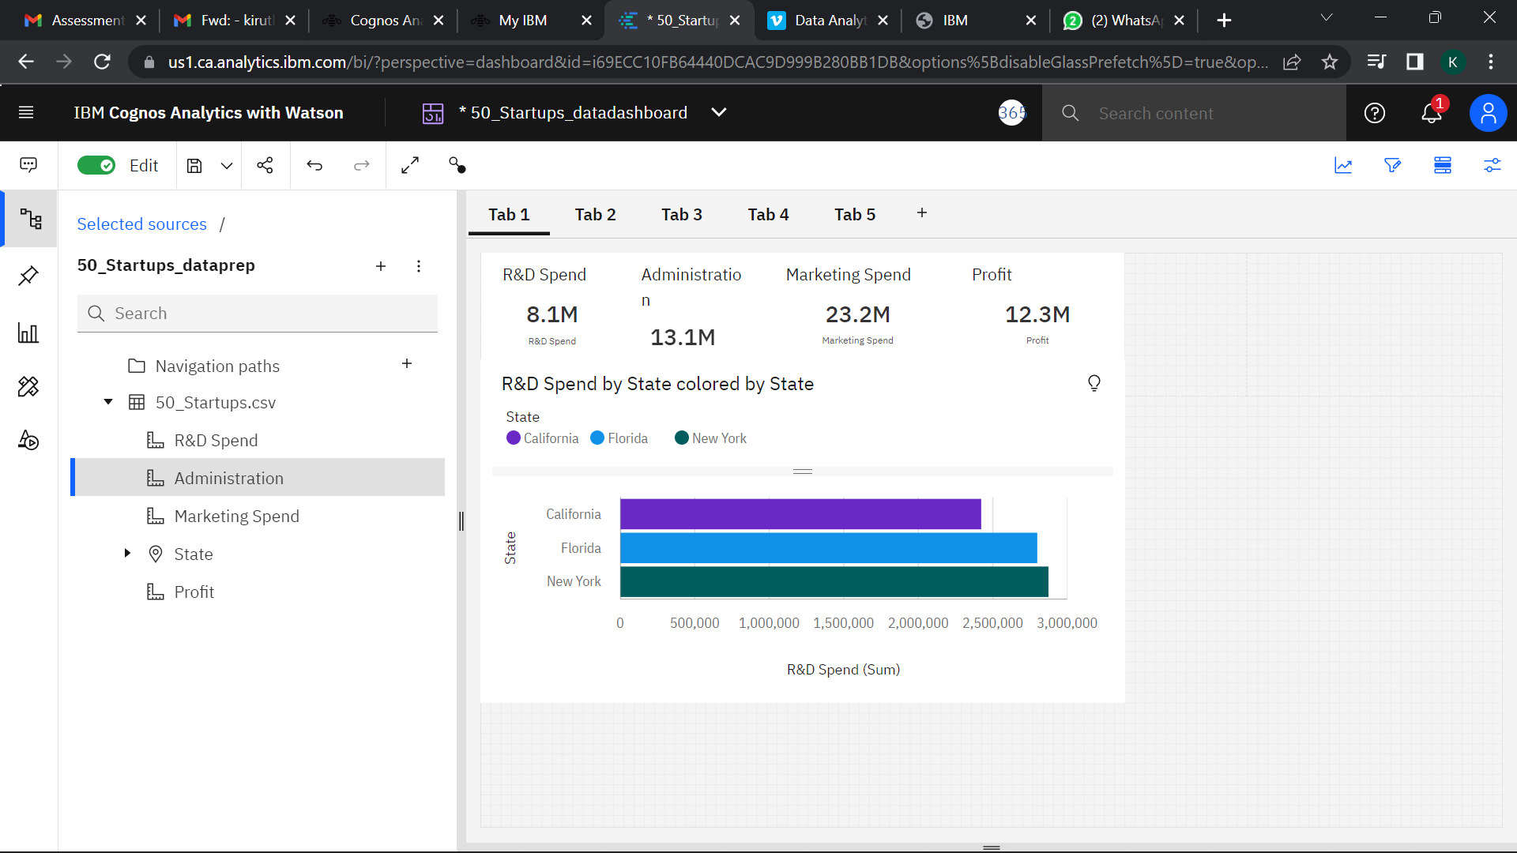

1. **Administration Spending**

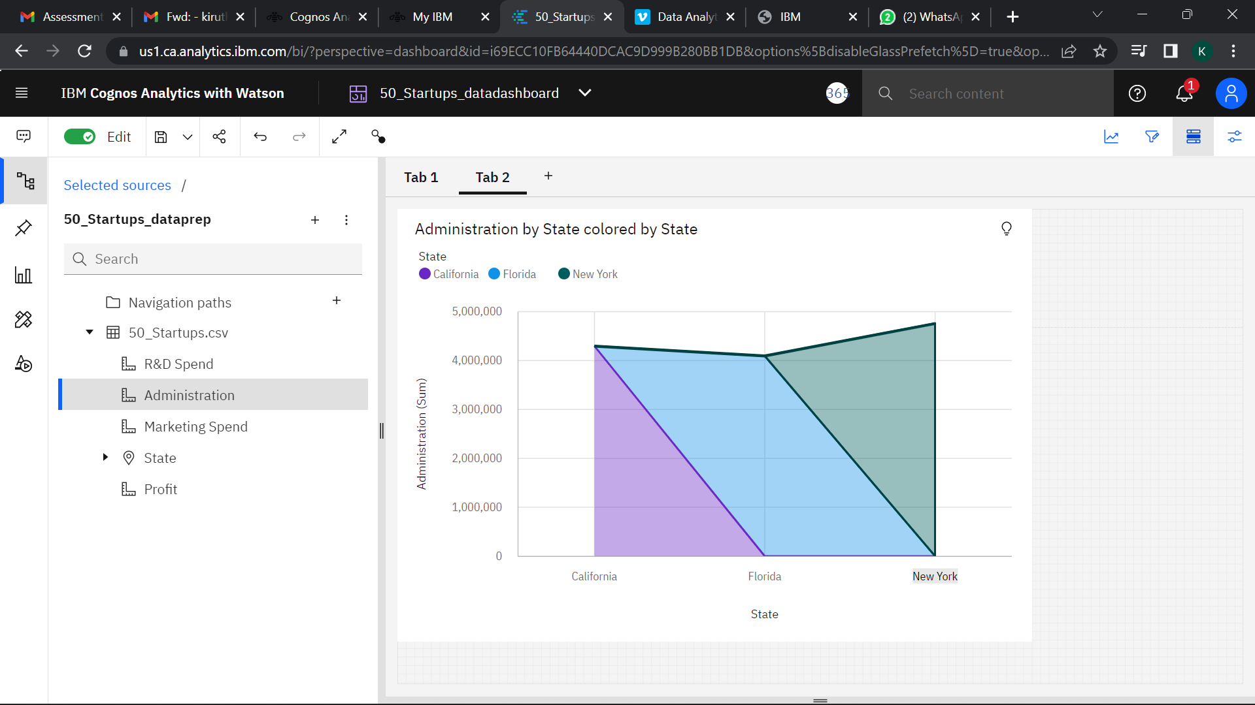

1. **Marketing Spending**

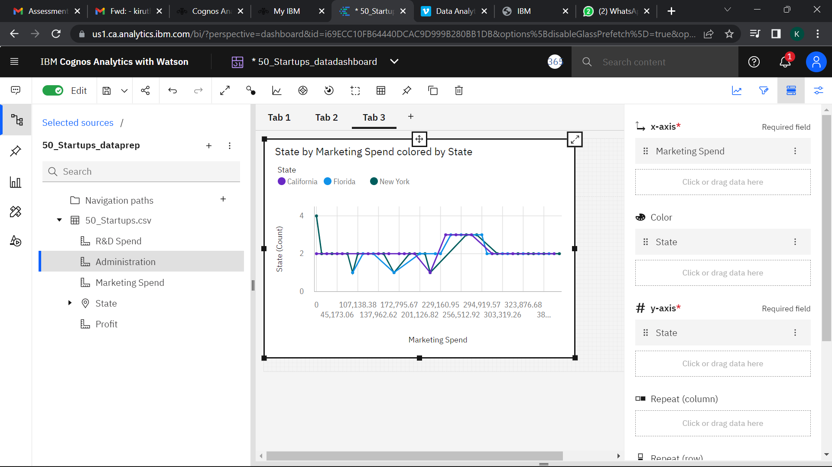

1. **State**

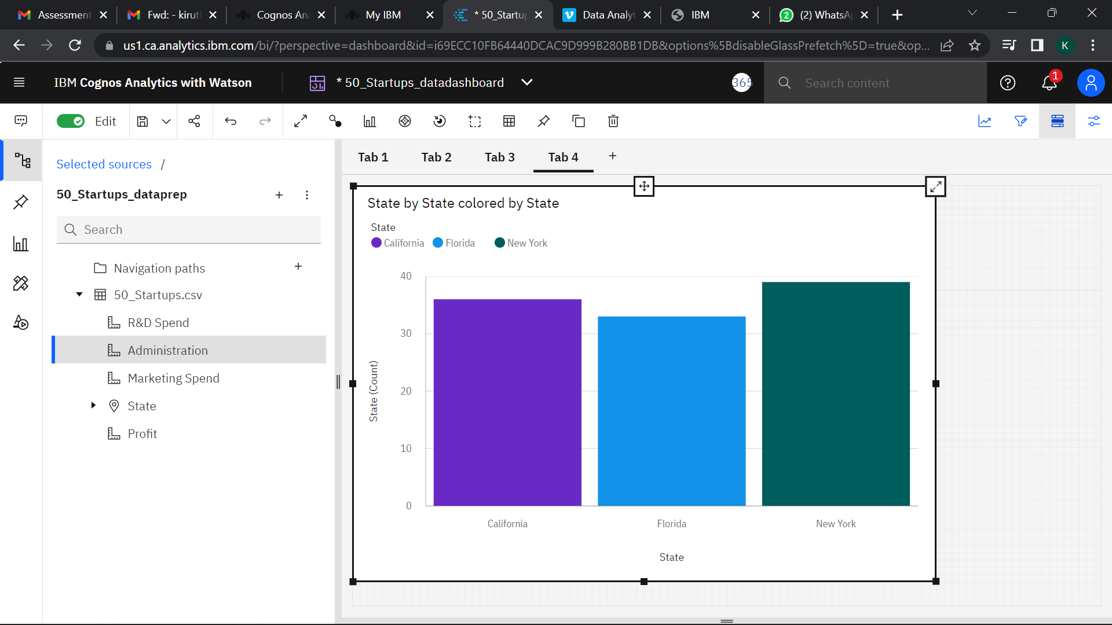

1. **Profit**

